Angular Pipes With Examples

**Diagrammatic representation of Pipe classification**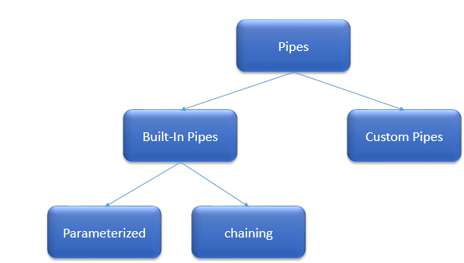

Below, we will look into the above concepts one by one with an example.

**Brief of Built-In Pipes**

* Angular 2 provides many built-in Pipes which include uppercase, lowercase, decimal, date, percent, currency etc.
* They are all available for use in any template in our Angular 2 project.

**Syntax -**  Property value | uppercase

**Simple Built-In Pipe example**

In this example, we will use uppercase pipes to change the employee name from lowercase letters to uppercase letters.

**FileName**

1. <!DOCTYPE html>
2. <html>
3. <head>
4. <title></title>
5. <meta charset="utf-8" />
6. </head>
7. <body>
8. <table>
9. <thead>
10. <tr>
11. <th>Code</th>
12. <th>Name</th>
13. <th>Gender</th>
14. <th>Annual Salary</th>
15. <th>Date of Birth</th>
16. </tr>
17. </thead>
18. <tbody>
19. <tr *ngFor='let employee of employees'>
20. <td>{{employee.code}}</td>
22. <td>{{employee.name|uppercase}}</td>
24. <td>{{employee.gender}}</td>
25. <td>{{employee.annualSalary}}</td>
26. <td>{{employee.dateOfBirth}}</td>
27. </tr>
28. <tr *ngIf="!employees || employees.length==0">
29. <td colspan="5">
30. No employees to display
31. </td>
32. </tr>
33. </tbody>
34. </table>
35. </body>
36. </html>

**Filename - app.component.ts**

1. **import** { Component } from '@angular/core';
3. @Component({
4. selector: 'my-app',
5. templateUrl: 'app/app.component.html'
6. })
7. **export** **class** AppComponent {
9. employees: any[] = [
10. {
11. code: 'emp101', name: 'karthik', gender: 'Male',
12. annualSalary: 5500, dateOfBirth: '25/6/1988'
13. },
14. {
15. code: 'emp102', name: 'sachin', gender: 'Male',
16. annualSalary: 5700.95, dateOfBirth: '9/6/1982'
17. },
18. {
19. code: 'emp103', name: 'rahul', gender: 'Male',
20. annualSalary: 5900, dateOfBirth: '12/8/1979'
21. },
22. {
23. code: 'emp104', name: 'mary', gender: 'Female',
24. annualSalary: 6500.826, dateOfBirth: '14/10/1980'
25. },
26. ];
27. }

**Output**

Before applying the uppercase pipe:  just FYI

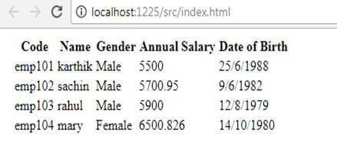  
Same output, after applying the Uppercase pipe

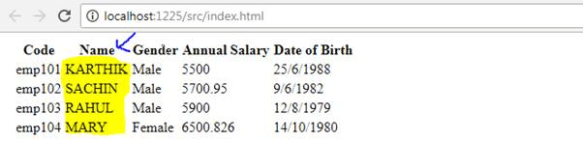

**Passing a parameter to Pipe**

A Pipe can take any number of optional parameters to get the expected output.

**Example**

In the below code, we will see the complete usage of date pipes

1. **import** { Component } from '@angular/core';
3. @Component({
4. selector: 'my-app',
6. template: `<div>
7. Parameterizing a pipe using DatePipe <br>
8. <p>---------------------------------------</p>
9. Medium:-{{DOB | date:"medium"}}<br/>
10. Short:-{{DOB | date:"short"}}<br/>
11. Specific Date Format:-{{DOB | date:"dd/MM/yyyy"}}<br/>
12. Short Time format:-{{DOB | date:"shortTime"}}<br/>
13. Medium Time:-{{DOB | date:"mediumTime"}}<br/>
14. Medium Date format:- {{DOB | date:"mediumDate"}}<br/>
15. Full Date Format:- {{DOB | date:"fullDate"}}<br/>

18. </div>  `
19. })
20. **export** **class** AppComponent {
22. DOB = **new** Date(1947, 8, 15)
23. }

**Output**

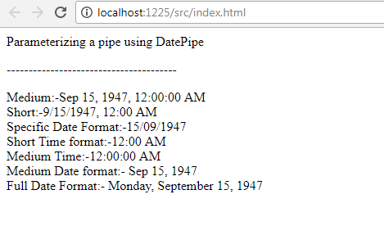

**Passing multiple parameters to Pipe**

Let's use a currency example for this, which will be most frequently used in our projects.

**Example**

1. **import** { Component } from '@angular/core';
3. @Component({
4. selector: 'my-app',
6. template: `<div>
7. Passing Multiple Parameter to Pipe<br>
8. <p>---------------------------------------</p>
9. Annual Income :-{{salary  | currency:'USD':**true**:'1.3-3'}}<br/>
11. </div>  `
13. })
14. **export** **class** AppComponent {
16. salary: number = 2602132
18. }

In the above code => currency:'USD': true:'1.3-3' is represent below,

* The first parameter 'USD' is currency type which can be of INR, USD or any currency type in the world.
* The Second parameter 'true' is a Boolean indicating whether to display currency symbol or not .By default it is false and, if we change it to true then the symbol will be displayed.
* The Third parameter '1.3-3' is a range limit of type string, which has the following format

**Format syntax - {minIntegerDigits}.{minFractionDigits}-{maxFractionDigits} => {1}.{3}-{3}**

* minIntegerDigits is a minimum number of integer digits to use. The Defaults value is 1.
* minFractionDigits is a minimum number of digits after fraction. The Defaults value is 0.
* maxFractionDigits is a maximum number of digits after fraction. The Defaults value is 3.

**Output**

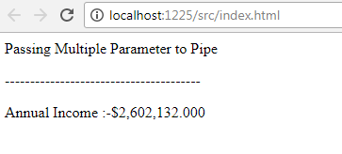

**Chain Pipes Example**

By using the advantage of chaining, we can use two different pipes for the same property or column. Let us see how to use uppercase and date together in our example below.

**Example**

1. **import** { Component } from '@angular/core';
3. @Component({
4. selector: 'my-app',
6. template: `<div>
7. chaining a pipe <br>
8. <p>---------------------------------------</p>
10. Full Date Format:- {{DOB | date:"fullDate"|uppercase}}<br/>

13. </div>  `
14. })
15. **export** **class** AppComponent {
17. DOB = **new** Date(1947, 8, 15)
18. }

**Output**

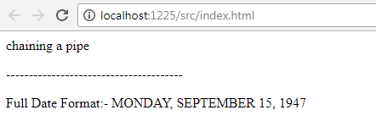  
**Custom Pipes**

To create a pipe in Angular 2, you have to apply the @Pipe decorator to class, which we can import from the core Angular library.

The @Pipe decorator allows you to define the pipe name that you'll use within template expressions.

**Syntax**

1. **import** { Pipe, PipeTransform } from '@angular/core';
2. @Pipe({ name: 'Pipename' })
4. **export** **class** Pipeclass **implements** PipeTransform {
5. transform(parameters): returntype { }
6. }

**Note**  
  
Transform() method will decide the input types, the number of arguments, and its types and output type of our custom pipe.

**Custom Pipe Example**

**Note**To easily understand, we will use same list example which we used in the above concept, and additionally provide the title (Mr. or Miss.) to the employees as per their gender value.

**Step 1**  
  
Create a file called employeeTitle.pipe.ts in the app folder. Add the code like below to that file.

**File Name - employeeTitle.pipe.ts**

1. **import** { Pipe, PipeTransform } from '@angular/core';
3. @Pipe({
4. name: 'employeeTitle'
5. })
6. **export** **class** EmployeeTitlePipe **implements** PipeTransform {
7. transform(value: string, gender: string): string {
8. **if** (gender.toLowerCase() == "male")
9. **return** "Mr." + value;
10. **else**
11. **return** "Miss." + value;
12. }
13. }

**Step 2**Register this newly created class in your existing root module like below:

**File Name-app.module.ts**

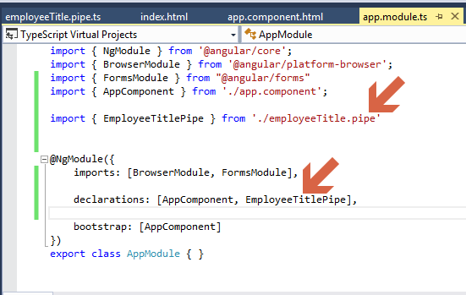

**Step 3**Add this line <td>**{{**employee.name | employeeTitle:employee.gender**}}**</td> to your existing HTML file called app.component.html.

**File name - app.component.html**

1. <!DOCTYPE html>
2. <html>
3. <head>
4. <title></title>
5. <meta charset="utf-8" />
6. </head>
7. <body>
8. <table>
9. <thead>
10. <tr>
11. <th>Code</th>
12. <th>Name</th>
13. <th>Gender</th>
14. <th>Annual Salary</th>
15. <th>Date of Birth</th>
16. </tr>
17. </thead>
18. <tbody>
19. <tr *ngFor='let employee of employees'>
20. <td>{{employee.code}}</td>
21. <td>{{employee.name | employeeTitle:employee.gender}}</td>
22. <td>{{employee.gender}}</td>
23. <td>{{employee.annualSalary | currency:'USD':**true**:'1.3-3'}}</td>
24. <td>{{employee.dateOfBirth}}</td>
25. </tr>
26. <tr *ngIf="!employees || employees.length==0">
27. <td colspan="5">
28. No employees to display
29. </td>
30. </tr>
31. </tbody>
32. </table>
33. </body>
34. </html>

That’s it.

**Final Output**

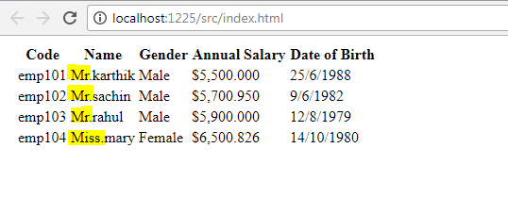

<https://www.angularjswiki.com/pipes/custompipe/>

https://www.angularjswiki.com/pipes/custompipe/#custom-pipe-example